The 1998 DBQ; modified for 2020
This is a broad prompt that really needs 10-15 documents to do it justice. In that regard, it’s a good example b/c Collegeboard will likewise have to ask a rather broad question with only 5 documents. So, you’ll really need your notes and good outside-the-document information.

PROMPT: Examine the extent to which political factionalism effected the social, political, and economic development of American society during the creation of the US Constitution and subsequent Early Federal Period, 1789-1800.
Document 1
“I believe we shall obtain a majority in the legislature of the United States, one devoted to the preservation of the federal Constitution, according to its obvious principles and those on which it was received; attached equally to the preservation to the states of those rights unquestionably remaining with them. We shall witness a majority firm in all those principles for which we have advocated, and the Federalists have uniformly opposed. Our country can never be harmonious while such a number of its citizens support principles which call for changes to the federal Constitution, eliminate protections for individual liberties therein, to destroy the state governments and consolidate them into one, and to monarchise that. Our country is too large to have all its affairs directed by a single government. The true theory of our Constitution is surely the wisest and best that the states are independent as to everything within themselves, and united as to everything respecting foreign nations.”
Thomas Jefferson to Gideon Granger, 1794

Document 2
“I have sometimes been ready to think that the passion for Liberty cannot be Equally Strong in the Breasts of those who have been accustomed to deprive their fellow Creatures of theirs. Of this I am certain that it is not founded upon that generous and Christian principal of doing to others as we would that others should do unto us . . . I long to hear that you have declared independence, and by the way in the new Code of Laws which I suppose it will be necessary for you to make I desire you would Remember the Ladies, and be more generous and favorable to them than your ancestors. Do not put such unlimited power into the hands of the Husbands. Remember all Men would be tyrants if they could. If particular care and attention is not paid to the Ladies we are determined to foment a Rebellion, and will not hold ourselves bound by any Laws in which we have no voice, or Representation. That your Sex are Naturally Tyrannical is a Truth so thoroughly established as to admit of no dispute, but such of you as wish to be happy willingly give up the harsh title of Master for the more tender and endearing one of Friend. Why then, not put it out of the power of the vicious and the lawless to use us with cruelty and indignity with impunity. Men of Sense in all Ages abhor those customs which treat us only as the vassals of your Sex. Regard us then as Beings placed by Providence under your protection and in imitation of the Supreme Being make use of that power only for our happiness.”
Letter, Abigail Adams to John Adams, 31 March 1776

Document 3
“The establishment of government credit, which enhances the ability to borrow, is a necessity if the nation is to endure. Considering the magnitude of the debt burden the country has inherited, which Congress wishes to dispose of it with haste, the only real difference of opinion was how much of the existing debt had to be satisfied in order to establish the government credit. None of the proposed measures, however, suggests defaulting on any portion of the $12 million foreign debt, as well as the $1.5 million in interest; we regard this as a sacred obligation to be paid in full. Credit, private or public, is of greatest consequence to every country. Of this, it might be called the invigorating principle . . . As to the existence of domestic debt, one of the effects of "assumption" would be to distribute the collective debt burden among all the states, the more solvent members paying a share of the more indebted ones. Most of the southern states have successfully paid down the bulk of their wartime debt.
To maintain our independence, the nation should encourage the growth of manufactures and regard it as a permanent, if not primary, feature of the economic system of the nation. We can achieve this by offering subsidies to industry, regulation of trade with moderate tariffs, which will not be intended to discourage imports but rather to raise revenue to support American manufacturing. Such subsidies, which would rely on revenue raised by moderate tariffs, would be the best means of growing manufacturing without decreasing supply or increasing prices of goods. Such encouragement through direct support would make American enterprise competitive and independent along with the nation as a whole. The nation should also support internal improvements, including roads and canals to increase and encourage domestic commerce, and other government encouragement as the need arises. Such notions will encourage the spirit of enterprise, innovation, and invention within the nation, and not only promote the growth of manufacturing but provide diversified employment opportunities and promoted immigration into the young United States. Growth of our infant nation into a manufacturing power will free the national economy from control by foreign powers, upon which the nation relies for their goods for domestic and especially defense supplies.”
Alexander Hamilton, First Report on Public Credit (1790); Report on Manufacturers (1791)

Document 4
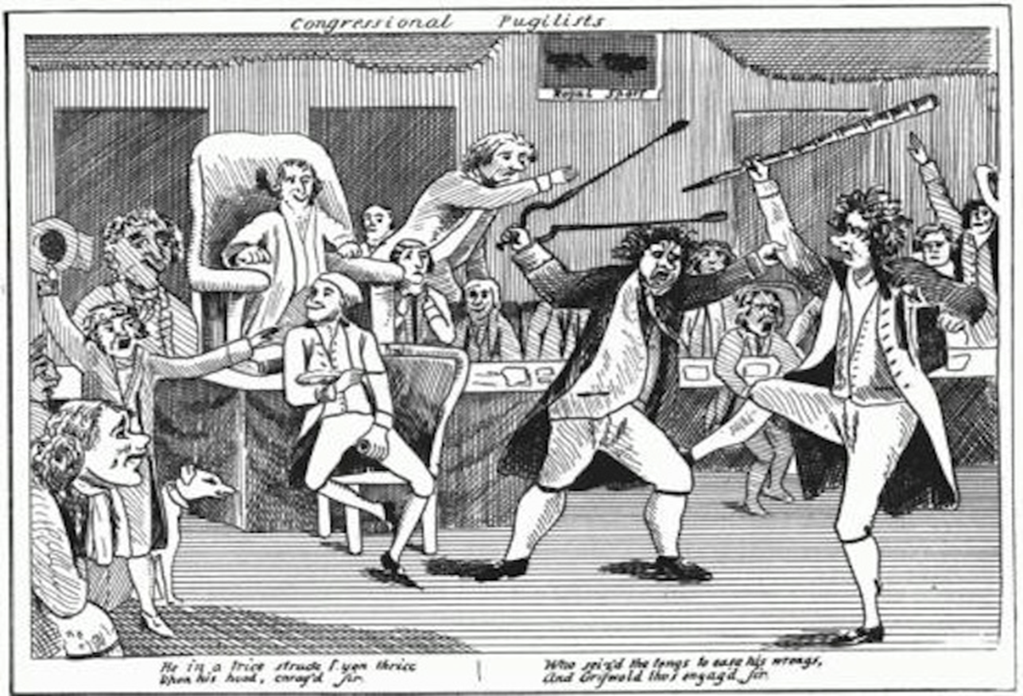
“Congressional Pugilists,” The Aurora, 1796,
© The New-York Historical Society

Document 5

A Proclamation:
Whereas, individuals determined to defeat the execution of the laws laying excise duties upon spirits distilled within the United States and upon stills have from the time of the commencement of those laws existed in some of the western parts of Pennsylvania.
These acts amount to treason, being overt acts of levying war against the United States, with persons having on the 16th and 17th of July proceeded in arms (on the second day amounting to several hundreds) to the house of John Neville, inspector of the revenue for the fourth survey of the district of Pennsylvania; having repeatedly attacked the said house with the persons therein, wounding some of them; having seized David Lenox, marshal of the district of Pennsylvania, who had previously seized while in the execution of his duty by a party of armed men, who detained him as a prisoner until, for the preservation of his life and the obtaining of his liberty, he agreed to forbear the execution of certain official duties relating to the collection of excise revenue; and finally forced the Harrisburg inspector of the revenue, from considerations of personal safety, to flee and to proceed to the seat of government, testifying that the motives of these outrages was the intention to prevent by force of arms the execution of the said excise collection laws and to oblige the said inspector of the revenue to renounce his said office . . . And whereas, by a law of the United States entitled "An act to provide for calling forth the national militia to execute the laws of the United States, suppress insurrections, and repel invasions," it is also noted that whenever the laws of the United States shall be opposed or the execution thereof obstructed in any state by circumstances too powerful to be suppressed by the ordinary course of judicial proceedings or marshals, “it shall be lawful for the President of the United States to call forth the militia of such state to suppress such combinations and to cause the laws to be duly executed . . . that, “whenever it may be necessary in the judgment of the President to use the military force called forth, the President shall forthwith command such insurgents to disperse and retire peaceably to their respective abodes, Therefore, and in pursuance of the proviso above recited, I, George Washington, President of the United States, do hereby command all persons, being insurgents, and all others whom it may concern, on or before the 1st day of September next to disperse and retire peaceably to their respective abodes.”
George Washington, Whiskey Rebellion Proclamation,
Claypoole's Daily Advertiser, 11 August 1794

